

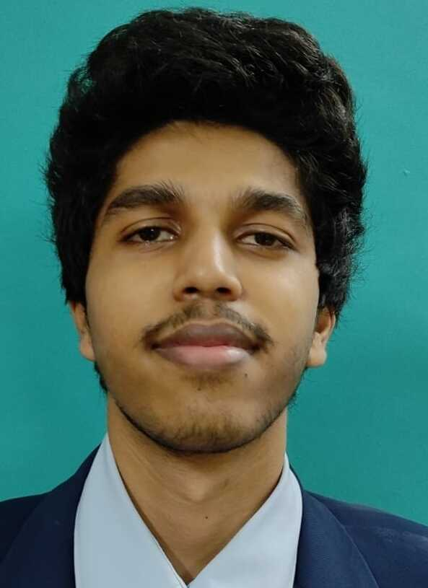

**Amogh Ganesh Lonare**

Male | 22

**lonareamogh@gmail.com**

+91 9082308859 **(Accredited by NAAC)**

# Career Objective

Seeking to get experience which helps in enhancing the knowledge.  
 Actively learning new analysis and programming tools such as R, Python and Data Science.

# Academic Qualification

|  |  |  |  |  |
| --- | --- | --- | --- | --- |
| **Qualification** | **School / Institute** | **Year** | **Board / University** | **Marks** |
| B. E (currently) Information Technology | A C Patil College of Engineering | 2021 | University of Mumbai |  |
|  |
| T. E Information Technology | 2020 |  |
|  |
| S. E Information Technology | 2019 |  |
|  |
| F. E Information Technology | 2017 |  |
|  |
| HSC - XII | Navneet College | 2017 | State Board of  Maharashtra |  |
| SSC - X | Kendriya Vidyalaya Colaba 1 | 2015 | State Board of  Maharashtra |  |

# Projects

**Flight Fair Prediction** *December 2020 - Present*

* Developing a **Machine Learning model** for predicting the flight prices given by **Supervised Learning**
* Analyzed the data using **exploratory analysis** and **visualization** using *scikit-learn and pandas* library

**Arduino Solar Panel (Mini Project)** *July 2020 – November 2020*

* Developed a method that allows Solar panel to always track and face the Sun for charging purpose
* The proposed method results in improving the efficiency of total supply of maximum power than traditional approach

# Technical Skills

|  |  |  |
| --- | --- | --- |
| Python | Arduino | HTML |
| CSS | Jupyter | SQL |

# Achievements

|  |  |
| --- | --- |
| **Technical** | * Participated in ABU ROBOCON INTERNATIONAL 2017 in a team of 12 * Achieved an All India Rank (AIR) of 16 |
| **Sports** | * Selected for regional level badminton team |